

CSF 3133

REKA BENTUK ANTARA MUKA BERASASKAN WEB

LAB REPORT 7

NAME: NIK MARIYAH SOFEAH BINTI MOHD RIZAN

MATRIC NUMBER: S76237

GROUP: K4

LECTURER: PROF.MADYA TS. DR. WAN NURAL JAWAHIR HJ WAN YUSSOF

DATE: 14/12/2025

SEMESTER I 2025/2026

Create Transparent Image Text

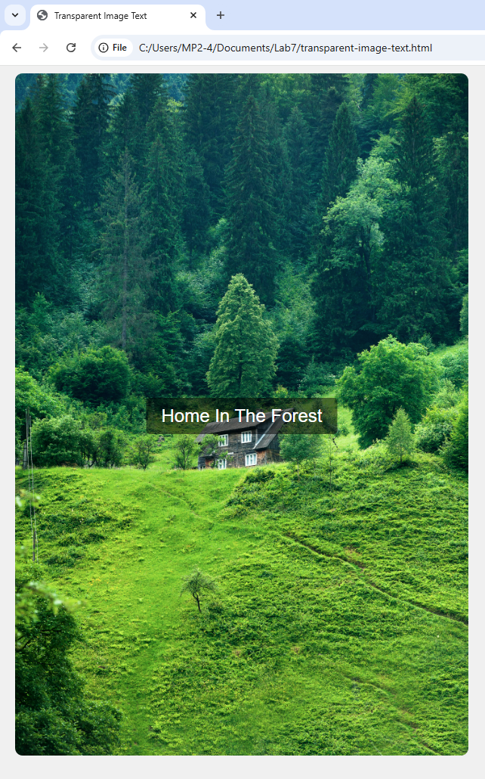

Create a Form on Image

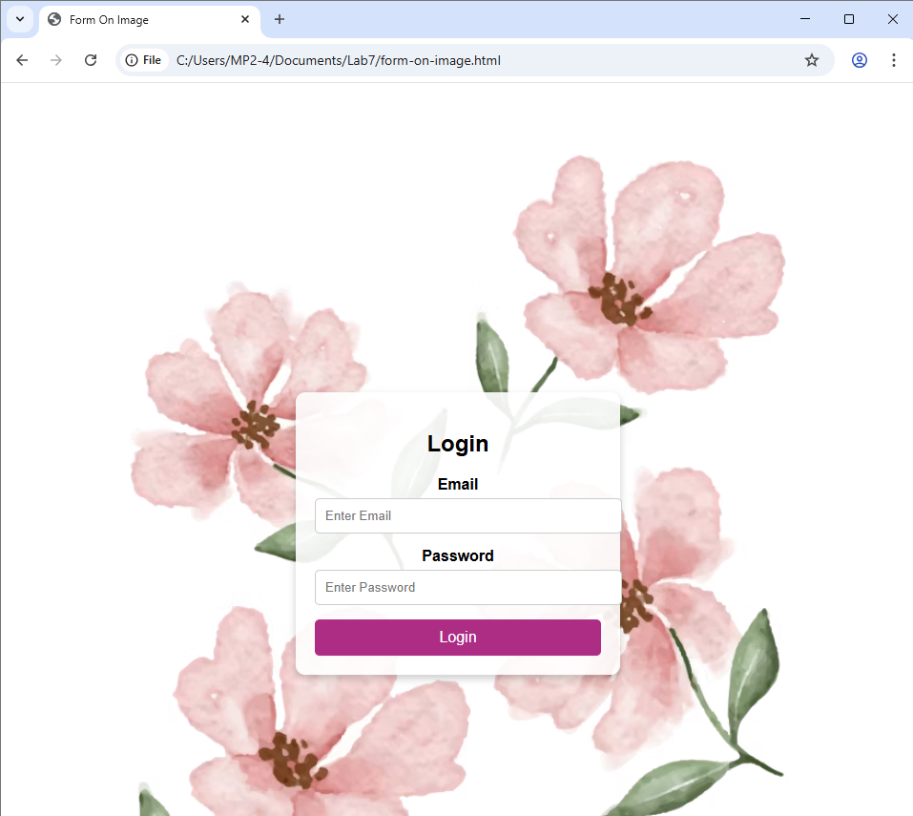

Create a Side Navigation Buttons

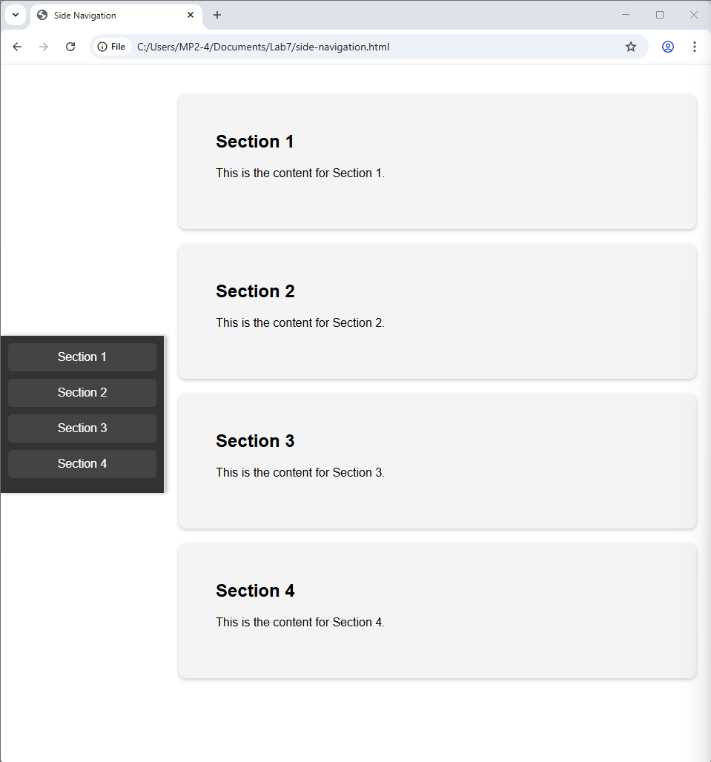

Create Automatic Slideshow

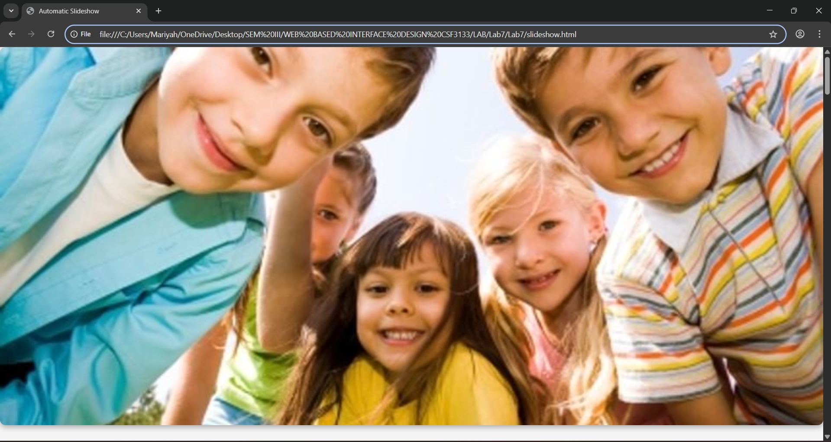

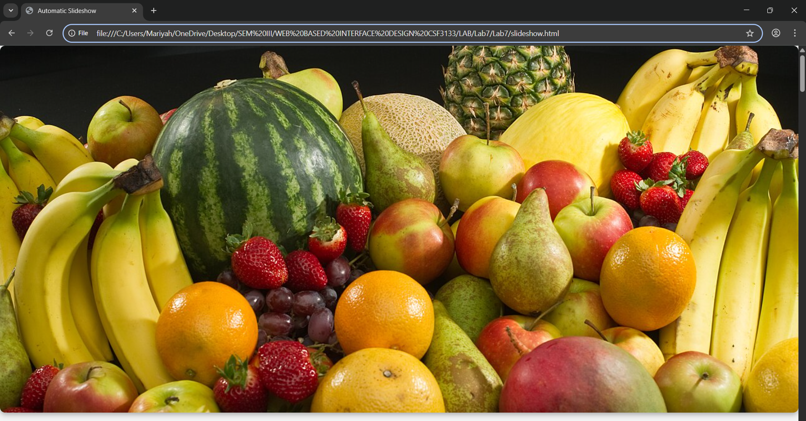

Create a Profile Page

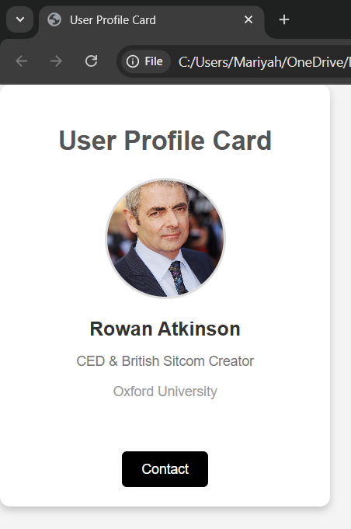

Create Progress Bar

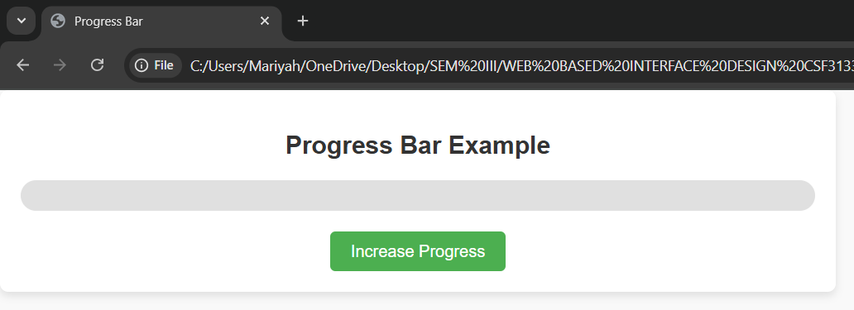

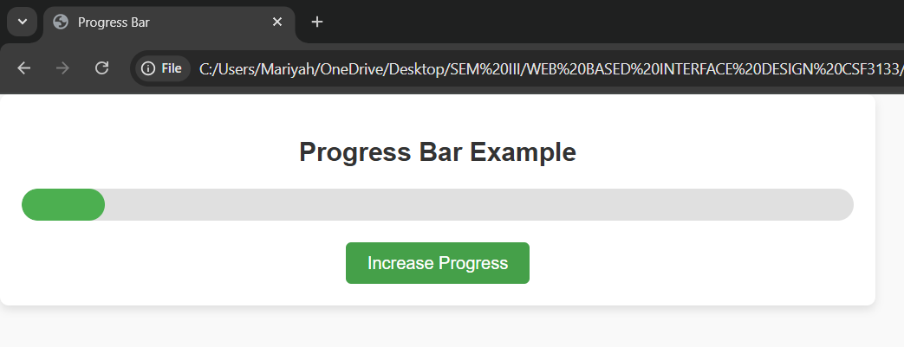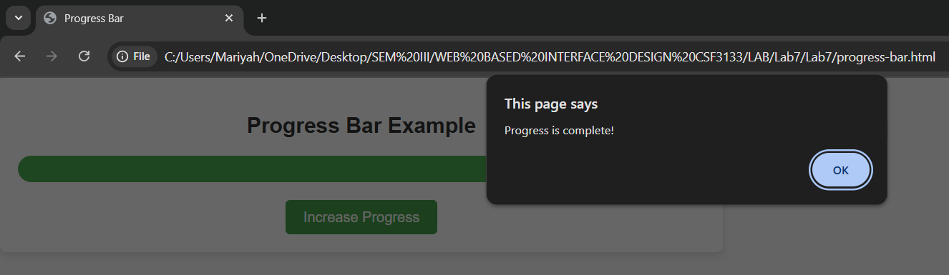

Create a Collapsible

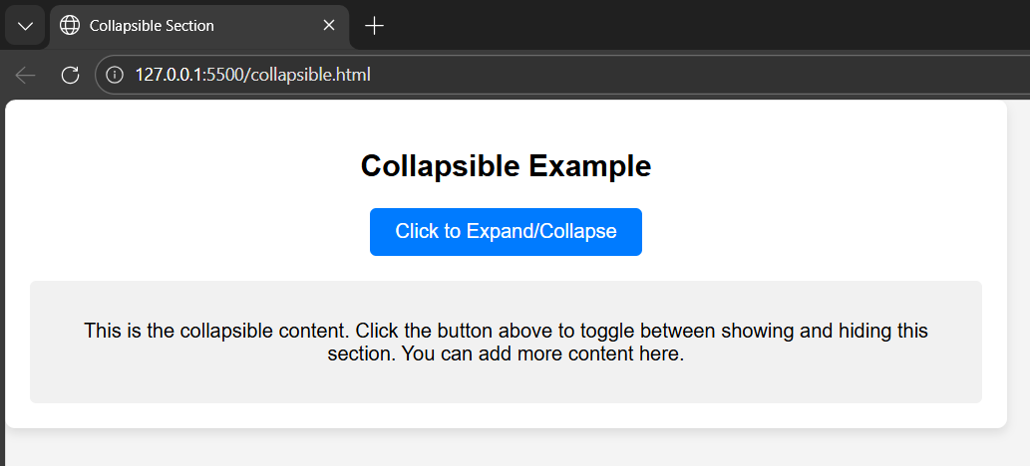

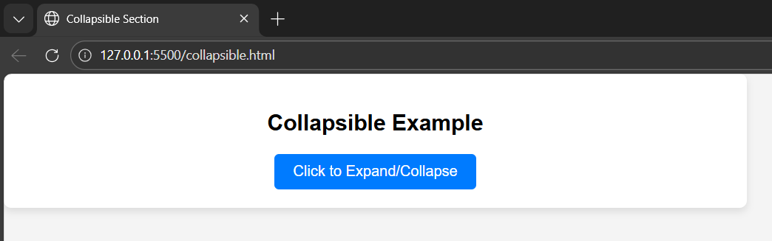

Lab Exercise